

**Saint Edmund’s and Saint Thomas’**

**Catholic Primary School**

**Oxford Road, Waterloo L22 8QF**

**Tel 0151 928 5586 Fax 0151 928 4352**

 

13th March 2020

Dear Parents,

**CORONA VIRUS UPDATE**

Amidst such uncertain times, I wanted to write to you to confirm our position in school in relation to the corona virus pandemic.

Whatever you think about the recent government decision to keep schools open at the moment, we remain committed to adopting a calm and measured approach whilst keeping our focus firmly on the children’s education.

We ask that you do not ask staff advice on whether your child should attend school if they are unwell. This decision can only be your decision, however the high temperature /continuous new cough (Corona Virus symptoms) dictate to all of us that a child should stay away from school for a minimum of seven days.

We will maintain the critical message about regular hand-washing for twenty seconds and will aim not to burden children with the wider concerns of this pandemic which grown-ups will have to manage.

In the meantime, I will meet with Local Authority representatives, Public Health and colleague Headteachers on Monday afternoon to understand what else schools can be doing to protect, to the best of our ability, all in our care.

The planned whole school visit to Chester Zoo has now been cancelled but will be rearranged when the situation improves. You will have received a flyer by email with a confirmation of this.

Thank you for your calm and sensitive support over the last few weeks in a challenging time for all

Yours sincerely,

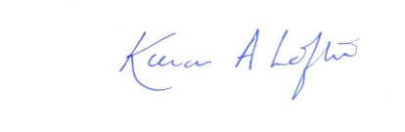

Kieran Loftus Headteacheer