

**Saint Edmund’s and Saint Thomas’**

**Catholic Primary School**

**Oxford Road, Waterloo L22 8QF**

**Tel 0151 928 5586 Fax 0151 928 4352**

 

*“Love, Learn and Live Like Jesus*

21st September 2021

Dear Parents,

Our school nurse, Joanne Windsor from the School Health Team, will recommence monthly drop-in visits to school on the last Thursday of the month starting on **Thursday 30th September 2021** between 2.30pm and 3.30pm. Appointments will be on a first come first seen basis. If you have any concerns about your child/children, you are very welcome to call to see her. Subsequent visits will be….

Thursday 21st October 2.30pm to 3.30pm (due to last Thursday being in half term)

Thursday 25th November 2.30pm to 3.30pm

Thursday 16th December 2.30pm to 3.30pm (due to last Thursday being in Christmas holiday)

Yours sincerely,

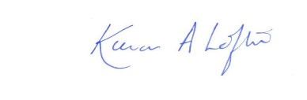

Kieran A Loftus

Headteacher