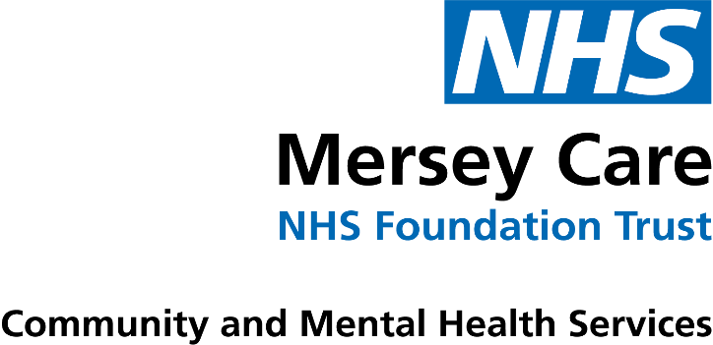

Dear Parent/Carer,
Your child’s annual flu vaccination is now due. This vaccination is recommended to help protect your child against flu. This year we will be offering the flu spray to those in Nursery to Year 6.
This year Mersey Care’s immunisation service has been asked by NHS England to offer the nasal flu vaccine to eligible children who attend a local authority nursery that is attached to a primary school. All children who are aged two or three years old on 31 August 2022 are eligible.
Flu can be an unpleasant illness and sometimes causes serious complications. Vaccinating your child will also help protect more vulnerable family and friends by preventing the spread of flu.
The vaccination is free and is a quick and simple spray up the nose. Even if your child had it last year, it is recommended to have the flu vaccine again this year.
Please visit the below link to access further information and complete your child’s consent form as soon as possible. The flu campaign is due to the start middle of September. Even if you don’t want your child to receive their flu spray please still complete the form, as this will avoid further communications from our service.
https://econsent.merseycare.nhs.uk/
If you are unable to complete the online form, please contact our team who will be happy to help. If after completing your child’s form, you attend the GP or wish to amend their form you must contact the immunisation team directly and not your child’s school.
Please see link below for a child friendly video on flu. You and your child may find it beneficial to watch prior to them being immunised.
https://www.youtube.com/watch?v=1jHWwm8NQUw
Yours sincerely
Sefton School Immunisation Service
0151 247-6130
mcn-tr.seftonimmunisationteam@nhs.net

