Anti-Bullying Week

During Anti-Bullying week Reception looked at what qualities make a person a good friend.

We made friendship cards to send to our friends.

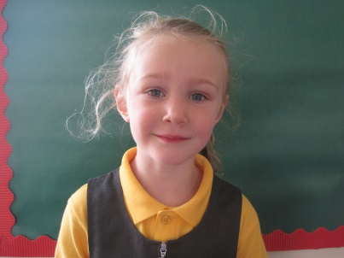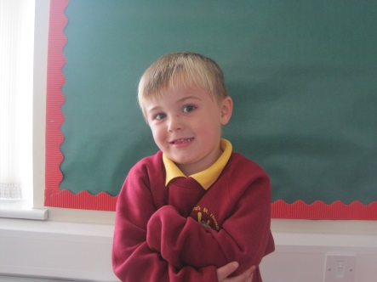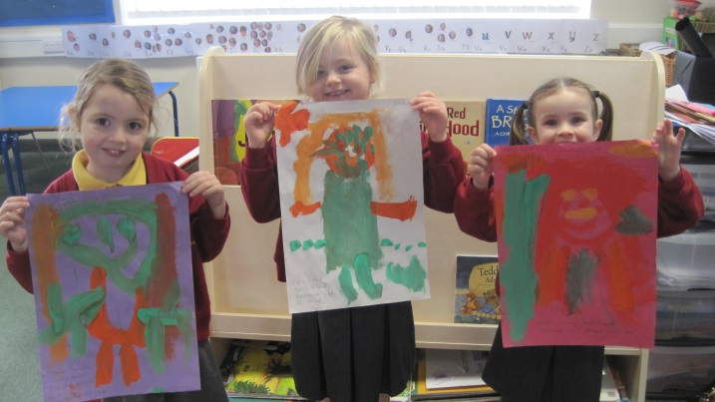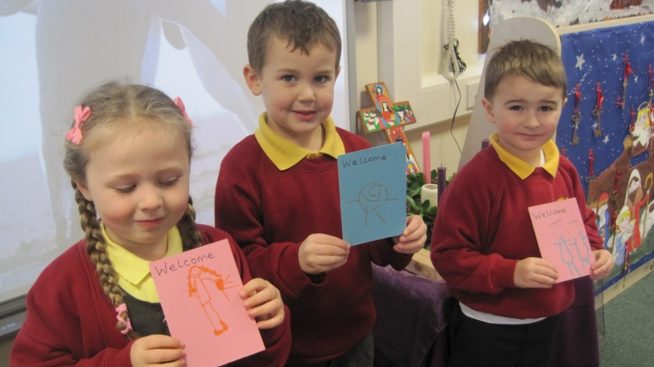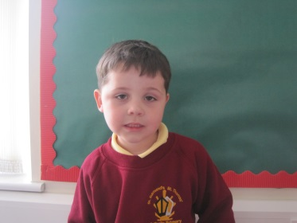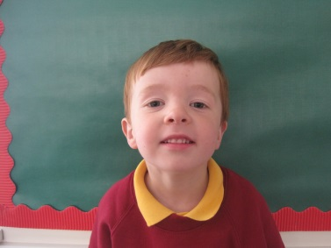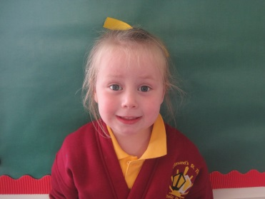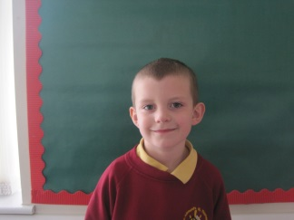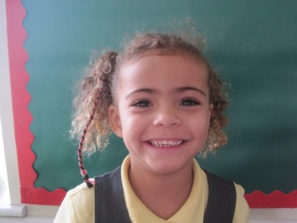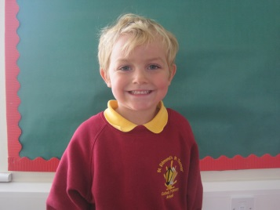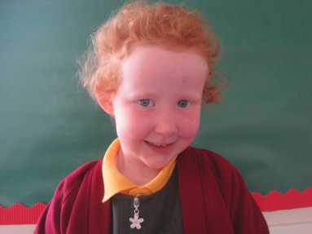

Isaac says spend time with your friends.

Olivia says smile at your friends.

**We thought about how we show friendship.**

We painted pictures of our friends.

Freddie says hug your friends.

James says be gentle with your friends.

Jacob says invite your friends to a party.

Halle says give them cakes and party drinks.

Charlotte says give your friends a cup of tea.

James says play games with your friends.

Olivia says share with your friends.