

**Saint Edmund’s and Saint Thomas’**

**Catholic Primary School**

**Oxford Road, Waterloo L22 8QF**

**Tel 0151 928 5586 Fax 0151 928 4352**

 

3rd February 2021

**CORONA VIRUS UPDATE 38 Early Years Reception and Non -Attending Nursery Parents Only**

Dear Parents

I am writing to you to seek your views on the current learning platform provision across the whole of the Early Years. If you are a Reception parent or a parent of a Nursery child who is **not choosing to send your child into Nursery at present.**

We have been operating Google Classroom for the whole school but Tapestry has been established for Nursery and Reception a long time before lockdowns. When we embraced Google Classroom, all Early Years staff received training and to date, both platforms can be used by staff for remote learning purposes.

Please could you indicate your preference for either continuing with the current arrangements or opting for one of the platforms exclusively. Your response will help us to review the provision and endeavour to improve the provision. Please email your response to

leadership.sest@schools.sefton.gov.uk

Thank you for your support in this matter

Yours sincerely

Kieran A Loftus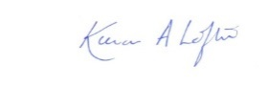 Alison Pritchard 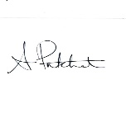

……………………………………………………………………………………………………………………………….

Name of child……………………………………Name of parent……………………

Class …………………………………………………………………. **Insert a** **X in the box**

Option 1 Retain both platforms

Option 2 Use Tapestry exclusively

Option 3 Use Google Classroom exclusively